|  |
| --- |
| JS Bank Branchless Banking System Integration |
| Functional Specifications Phase-1 |
| May 28, 2014 |
| 1.0 |



Contents

1 Introduction 2

1.1 Scope 2

a. Solution Overview 2

b. Channels Summary 2

c. Host Systems Summary 2

d. Business Context 3

e. Referred Documents 3

f. Reference Documents 3

g. Acknowledgement 3

1.2 Assumptions & Constraints 3

1 Functional Specifications - Rendezvous 5

1.1 List of Transactions 5

1.2 Message Format 5

1.3 T24 Host Level Changes 5

1.4 Transaction flows 5

2 Functional Specifications – Vision 9

2.1 Transaction Log Report 9

2.2 Channel Wise Transaction 11

2.3 Company Wise Transaction Report 12

2.4 Utility Transaction Log Report 14

2.5 Fund Transfer Detail Report 15

3 Functional Specifications – Ambit 17

3.1 Wallet Account Menu 17

3.2 Fund Transfer JS to Wallet 17

3.3 Beneficiary Management 20

4 Out of scope 25

Change History

|  |  |  |  |
| --- | --- | --- | --- |
| **Revision** | **Date** | **Author(s)** | **Description** |
| 0.1 | 28/05/2014 | Muhammad Adeel Ashraf | Initial draft |
| 0.2 | 28/05/2014 | M Danish Siddique | Added Vision Section |
| 0.3 | 30/05/2014 | Muhammad Adeel Ashraf | JS feedback incorporated |
| 1.0 | 30/05/2014 | Muhammad Adeel Ashraf | Feedback incorporated |
| 1.1 | 02/06/2014 | Muhammad Aamir Khan | Feedback Reviewed |

1. Introduction

JS Bank takes an initiative to facilitate its enterprise-wide customer and provide branchless banking solution.

JSBL select Innov8’s Branchless banking solution to be integrated with Rendezvous as a channel for transactions routing to the host systems. JS Bank also showed wish to integrate branchless bank Host system with Rendezvous for transactions initiating from Delivery channels.

The overall scope has been categorized in two major portions. First is the mandatory requirement in order to have branchless banking solution functional and other is the detailed requirements which can be requested by JS bank as a part of same project or different phase This FS will only cover Phase 1 requirements.

* 1. Scope
     1. Solution Overview

This section to be updated

* + 1. Channels Summary

|  |  |  |  |
| --- | --- | --- | --- |
| **Sr#** | **Host-end** | **Description** | **Connectivity** |
| 1 | Branchless Banking Channel | Innov8 Branchless Banking Solution (Channel interface) | RDV8585 TCPIP |
| 2 | Ambit | JS Bank Internet Banking | TCPIP |
| 3 | 1-Link Switch | Country Switch | TCPIP |

* + 1. Host Systems Summary

|  |  |  |  |
| --- | --- | --- | --- |
| **Sr#** | **Host-end** | **Description** | **Connectivity** |
| 1 | Branchless Banking Host | Innov8 Branchless Banking Solution (Host interface) | RDV8585 TCPIP |
| 2 | SmartPAY | SmartPAY provides a message-based interface for the clients to perform bill presentment and bill payment transactions. | Fixed Length TCPIP |
| 3 | Host T24 | JSBL Core Banking Host | ISO TCPIP |

* + 1. Business Context

This section to be updated

* + 1. Referred Documents
* [JS Bank] Integration with Branchless Banking Solution v 1.3 (Phase 1).docx
* SmartPAY Message Interchange Format ver1.5.pdf
* Email Communications
  + 1. Reference Documents
* Rendezvous 8583 Message Format.doc
* [JSBL][Branchless Banking] Rdv-BB Banking Message Format Specificationsv0.2.doc
* SmartPAY Message Interchange Format ver1.5.pdf
  + 1. Acknowledgement

Avanza Solutions will be thankful to JS Bank for valuable efforts and contribution in the completion of requirements analysis phase.

* 1. Assumptions & Constraints

This section describes various assumptions and responsibilities of different parties for successful deployment of Phase 1 of this project;

* RDV will not send any debit customer account transaction upon Bill Payment
* Micro Finance Bank System will be responsible to maintain all Limits. RDV will not perform any limit checks for any transaction request from BB Channel.
* Micro Finance Bank System will be responsible to maintain all permissions. RDV will not perform any permission checks for any transaction request from BB Channel
* Prepaid and Debit Card will work as per production only in case of Ambit JSBL to Wallet Account. JS Bank will explicitly inform in case of any modifications in existing flows.
* 1Link UBPS will be the only Billing aggregator to be integrated in this project
* Any Reversal handling for Wallet account will not be part of the scope
* No Wallet to JSBL Account linking will be covered in Phase 1
* Permission and limits will not be managed by Vision
* Same limit and permission will be used for Ambit as currently in production for JSBL Account
* Standard Vision transaction reports will also be showing BB transaction with the respected code
* New channel will be added for BB/innov8 for report filtering.
* There should be a flag required for UBPS transaction whether it’s done through NADRA or 1 link
* One customize report required by JS bank for BB, so we will finalize the field and format accordingly during FS analysis
* JS bank will confirm, is there any Export file required for innov8 from Vision? If required, then they have to provide the export file format
* Fund Transfer screen will be added to Ambit Internet Banking, Fund Transfers to Wallet Account.
* Beneficiary Management included in part of Phase 1 scope
* JS Bank will provide SmartPAY Test BED for Bill Inquiry and Bill Payment during SIT/UAT
* JS Bank will provide 1Link Test BED for Incoming IBFT during SIT/UAT
* In case T24 not response with success for Funds Transfer, transaction will stuck in SAF after retried exhaust and JS Bank will manually settle accounts.
* No Settlement will be done between RDV and Branchless Banking Host
* Multiport project has been moved to production.
* JS Bank will ensure Innov8 vendor availability and T24 readiness ahead of committing any dates to Avanza. Avanza will disengage resources due to any delays from JSBL and resource re-engagement date will be communicated by Avanza
* All pre-requisites readiness will be ensured by JS Bank prior to providing commence dates
* Message Format is part of the scope

1. Functional Specifications - Rendezvous
   1. List of Transactions

Following is the list of Transactions which will be developed:

|  |  |
| --- | --- |
| Transactions | High level flow |
| Utility Bill Inquiry | Smart Phone->Branchless Banking Channel -> RDV ->SmartPAY |
| Utility Bill Payment | Smart Phone-> Branchless Banking Channel -> RDV ->SmartPAY |
| JSBL Account Title Fetch | Smart Phone-> Branchless Banking Channel -> RDV -> T24 |
| JSBL Account Funds Transfer | Smart Phone-> Branchless Banking Channel -> RDV -> T24 |
| Wallet Account Title Fetch | Ambit -> RDV -> Branchless Banking Host |
| Wallet Account Funds Transfer | Ambit -> RDV -> Branchless Banking Host |
| Wallet Account Title Fetch for IBFT | 1LinkSwitch -> RDV -> Branchless Banking Host |
| Wallet Account Funds Transfer for IBFT | 1Link Switch -> RDV -> Branchless Banking Host |

* 1. Message Format

This Functional Specifications document will use Message format document mentioned under section Referenced Documents.

* 1. T24 Host Level Changes

Rendezvous – T24 will reuse T24 Funds Transfer ISO message from production with new TranCode for JSBL Account FT in Branchless Banking integration project. There will be no changes in existing ISO FT.

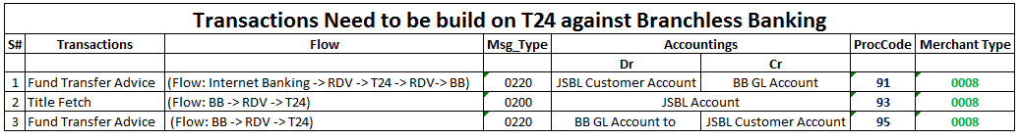

* 1. Transaction flows

Below are the snap shots of transactions wise workflows for understanding purposes. There might be few modifications during SIT after customer consents.

### Utility Bill Inquiry

* Branchless Banking Channel will send Bill Inquiry transaction to RDV
* RDV will look-up configuration table in Vision database and read Billing aggregator ID. This is for future references and this project will only cover 1Link UBPS as Billing Aggregator.
* RDV will populate bill inquiry structures for SmartPAY
* RDV will send Bill Inquiry request to SmartPAY
* SmartPAY will response back to RDV with Success or failure
* RDV will send response code with Billing details back to Branchless Banking Channel

### Utility Bill Payment

* Branchless Banking Channel will send Utility Bill Payment transaction to RDV.
* RDV will read request parameter “BillPaymentAggregatorCode“ from channel for Payment Aggregator. If invalid BillPaymentAggregatorCode found, RDV will decline transaction with –ve response code. Currently only SmartPay billing aggregator will be considered as valid in request.
* RDV will populate Bill payment structures for SmartPAY
* RDV will send Bill payment request to Bill Payment Aggregator
* SmartPAY will response back to RDV with Success or failure
* RDV will send response code(success/failure) to Branchless Banking Channel

### JSBL Account Title Fetch

* Branchless Banking channel will send JSBL Account Title Fetch inquiry transaction to RDV
* RDV will check JSBL Account limits and permissions as per production. JSBL will specifically inform in case of any modifications.
* Upon successful validation, RDV will route the request to T24
* T24 Host will return Title of Account to RDV
* RDV will send response code and JSBLAccount Title to BB Channel

### JSBL Account Funds Transfer (Advice Message)

* Branchless Banking channel will send JSBL Account Funds Transfer advice message to RDV
* RDV will not check any limits and permissions
* RDV will send the advice to SAF
* Upon successful SAF addition, RDV will send success response to Branchless banking channel
* RDV GMD will read entry from SAF and populate structures
* RDV GMD will send the FT advice message to T24 Host
* T24 Host will response back with success to RDV. In case T24 not response with success, transaction will stuck in SAF after retried exhaust, JS Bank will manually settle accounts
* RDV will mark the advice as processed in SAF.

### Incoming IBFT Title Fetch for Wallet Account

* 1Link Switch will send IBFT Account Title Fetch inquiry transaction to RDV
* RDV will not perform any Account limits and permissions.
* RDV will route the request to Branchless banking Host
* Branchless banking Host will response success or failure along with available balance to RDV
* RDV will send the response code with Wallet Account Tile to 1Link Switch

### Incoming IBFT (Advice) for Wallet Account

* 1Link switch will send IBFT Credit advice message to RDV
* RDV will not check any limits and permissions
* RDV will send the advice message to SAF
* Upon successful SAF addition, RDV will send success response to 1Link Switch
* RDV GMD will read entry from SAF and populate structures
* RDV GMD will send the FT advice message to Branchless Banking Host
* Branchless Banking Host will send response with success to RDV. In case Branchless Banking Host do not response with success, transaction will stuck in SAF after retried exhaust, JS Bank will manually settle accounts
* RDV will mark the advice as processed in SAF.

### Wallet Account Title Transfer

### Wallet Account Funds Transfer (Advice)

1. Functional Specifications – Vision

### Standard Reports Changes

All branchless banking transactions can be viewed by using the existing following Transaction reports already available on Vision. A new option (Branchless banking) in channel filter will be available to view branchless Banking transactions.

* Transaction log report
* Channel Wise Transaction Report
* Company Wise Transaction report
* Utility Transaction Report
* Fund Transfer Detail Report
  1. Transaction Log Report

Filter Screen for Transaction log report.

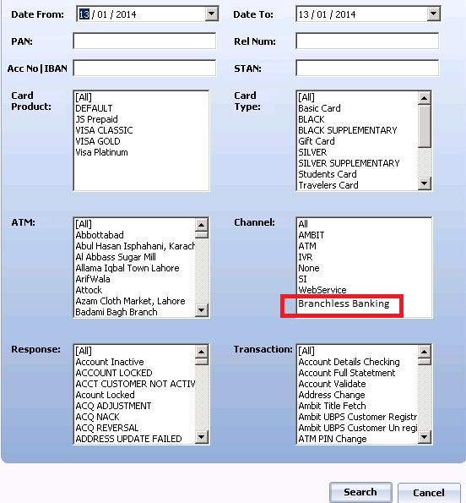

View of Transaction log Report

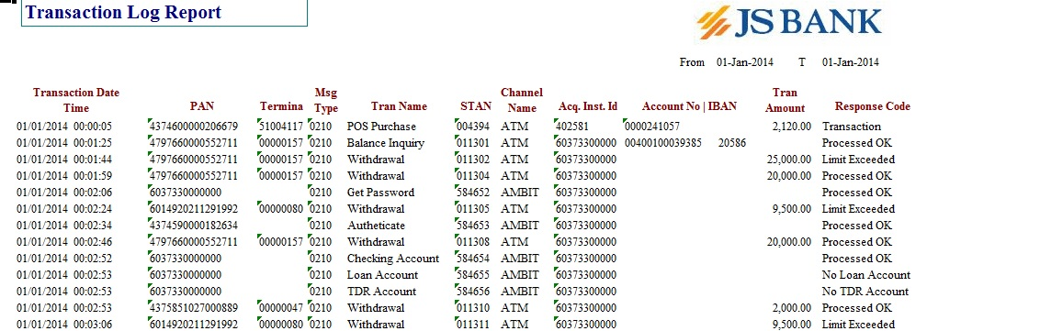

Following column will be displayed on transaction log report.

* Transaction Date Time
* PAN (Empty for branchless banking)
* Terminal (Empty for branchless banking)
* Message type
* Transaction Name
* STAN
* Channel Name
* Acquirer Instrument Id
* Account No
* Transaction Amount
* Response Code
  1. Channel Wise Transaction

Filter Screen for Channel Wise Transaction report

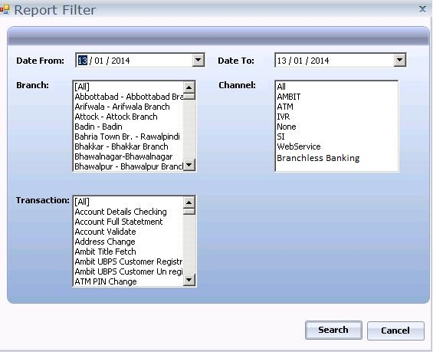

Channel Wise Transaction report view

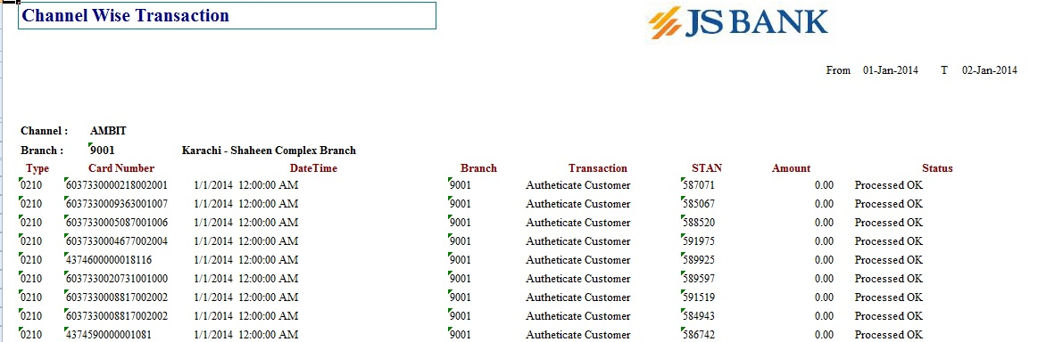

Channel wise transaction report has groping on Channel and Branch:

For branchless banking channel will be branchless and branch will be empty or UNKNOWN and display following columns:

* Message Type
* Card Number (Empty for branchless banking)
* Date Time
* Branch (Empty for branchless banking)
* Transaction
* STAN
* Amount
* Status
  1. Company Wise Transaction Report

Filter Screen for Company Wise Transaction report

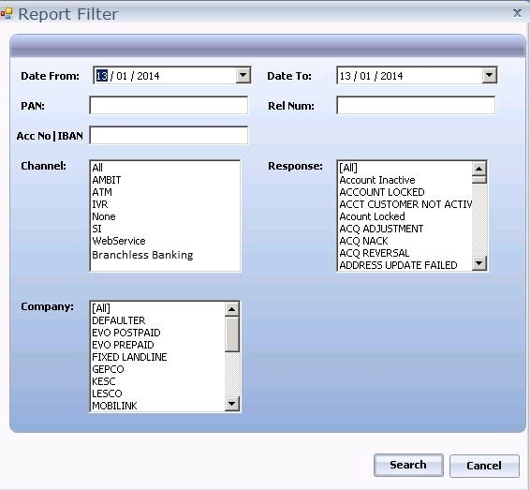

View of Company Wise Transaction report.

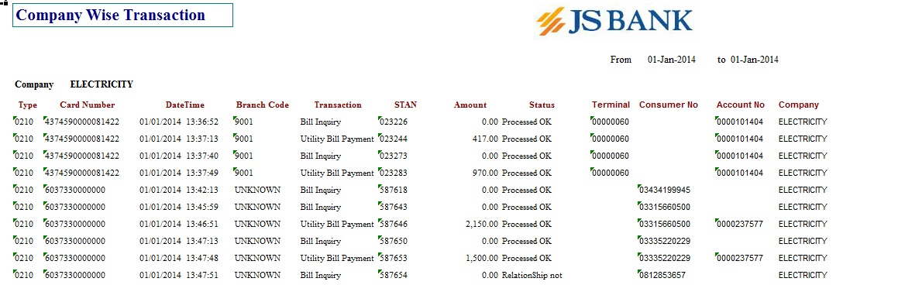

Following column will be displayed on company wise transaction report.

* Message Type
* Card Number
* Date Time
* Branch Code
* Transaction
* STAN
* Amount
* Status
* Terminal (Empty for Branchless banking)
* Consumer Number
* Account Number
* Company
  1. Utility Transaction Log Report

Filter Screen for Company Wise Transaction report

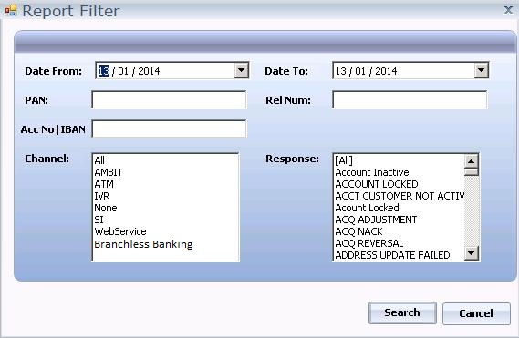

View of Utility Transaction log report

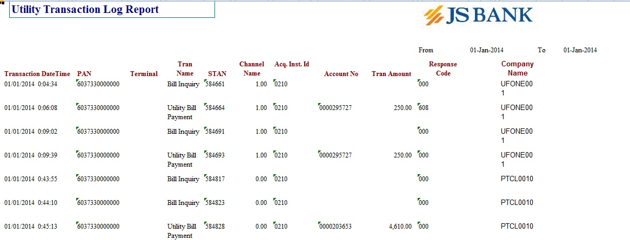

Following column will be displayed on company wise transaction report.

* Transaction Date Time
* PAN
* Terminal
* Transaction Name
* Channel Name
* Acquirer Instrument Id
* Account Number
* Transaction Amount
* Response Code
* Company Name
* Billing Aggregator (This phase only cover 1 link UBPS)
  1. Fund Transfer Detail Report

Filter Screen for Fund Transfer report.

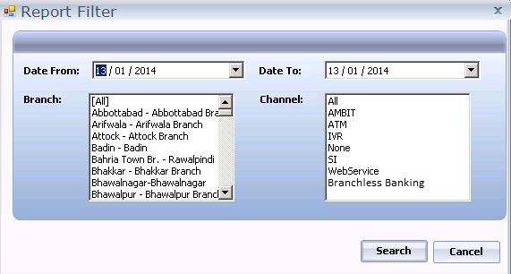

View of Fund transfer Report.

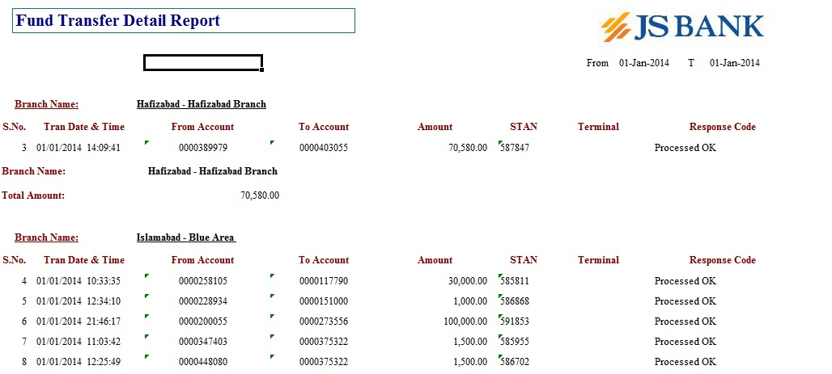

Channel wise transaction report has groping on Branch:

For branchless banking branch will be empty or UNKNOWN and display following columns:

* Serial Number
* Transaction Date Time
* From Account
* To Account
* STAN
* Terminal
* Response Code

1. Functional Specifications – Ambit
   1. Wallet Account Menu

All Wallet Account-related features will be clubbed together under a separate menu item “Wallet Account”.

The following sub-menu items are available in this Phase:

* Fund Transfer JS to Wallet
* Beneficiary Management
  1. Fund Transfer JS to Wallet

The user selects “Fund Transfer JS to Wallet” option from the Wallet Account Menu. Following Screen is shown.

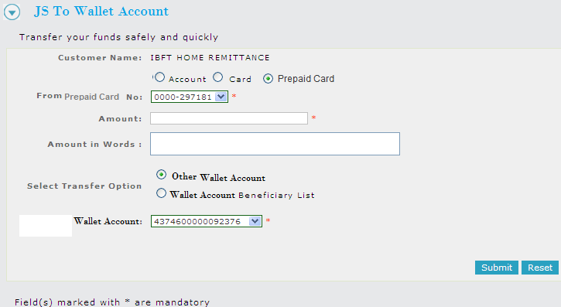

Figure – Fund Transfer – JS to Wallet Account - Main Screen

**Input Fields**

|  |  |  |  |  |  |
| --- | --- | --- | --- | --- | --- |
| Field | Type | Length | Mandatory | Enabled | Description |
| From Account/ Card / Prepaid Card | RadioGroup |  | Y | Y | To select whether the user wants to specify an Account Number or a Card Number (and hence, the default account linked with that card) as the source account  If “Account” Radio Button is selected, a “From Account No” drop-down list becomes visible  If “Card” Radio Button is selected, a “From Card No” drop-down list becomes visible  If “Prepaid Card” Radio Button is selected, a “From Prepaid Card No” drop-down list becomes visible |
| Amount | TextBox | 1 – 12 | Y | Y | Numeric. Value must be between 1 and 1,000,000,000 inclusive |
| Amount in Words | TextBox | 1 – 10 | Y | N | A textual description of the value entered in the “Amount” field (auto filled) |
| Select Transfer Option | RadioGroup |  | Y | Y | Specifies the nature of funds transfer and contains the following options (only one can be selected):   * Other Wallet Account * Wallet Account Beneficiary List   Relevant GUI fields and made visible and invisible depending on the option selected from this group to facilitate that particular type of funds transfer. |
| Other Wallet Account | TextBox | 20 | Y/N | Y/N | User will input Wallet Account Number |
| Wallet Account Beneficiary List | Dropdown |  | Y/N | Y/N | User Will select wallet account beneficiary from drop down |

**Navigation**

The following navigation links/ options will be available on this page:

|  |  |  |
| --- | --- | --- |
| Option | Type | Description |
| Submit | Button | Submits the form but does not immediately initiate the Funds Transfer transaction; instead, displays a Confirmation Screen. Title fetch is called. |
| Reset | Button | Clears all selections/inputs made on the form. |

A confirmation screen is the final step before funds transfer transaction is actually carried out:

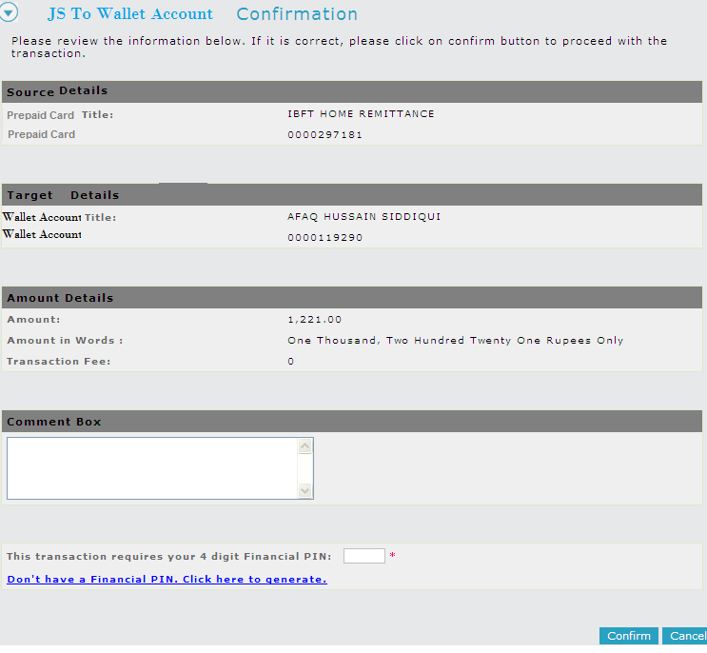

Figure – Fund Transfer – JS to Wallet Account - Confirmation Screen

The confirmation screen displays in readable form the selections made on the previous form for Funds Transfer:

* From Account No. (In case a Card Number was specified on the previous form, the default account against that card will be displayed here. If prepaid card is selected then card number will be displayed)
* From Account Title
* To Wallet Account No
* To Wallet Account Title
* Amount
* Amount in Words
* Transaction Fee

**Input Fields**

|  |  |  |  |  |  |
| --- | --- | --- | --- | --- | --- |
| Field | Type | Length | Mandatory | Enabled | Description |
| FPIN | TextBox | 4 | Y | Y | The 4-digit Financial PIN to authorize the Transaction |

**Navigation**

The following navigation links/ options will be available on this page:

|  |  |  |
| --- | --- | --- |
| Option | Type | Description |
| Confirm | Button | Submits the form and proceeds to perform the Funds Transfer transaction. All field-level constraints must be met apart from the following conditions:   * The FPIN is valid * The FPIN has not expired |
| Cancel | Button | Takes the user to the previous form |

Upon confirmation and transaction completion, a status message is displayed to the user.

An e-mail will be dispatched to the user (if he/she subscribed to email notifications during registration) containing the transaction details for future reference. An option to “Print Receipt” or “Export in PDF” will also be provided on this Status Message screen.

* 1. Beneficiary Management

Through this functionality, a logged in user can create and manage wallet account beneficiaries which then appear in “JS-To-Wallet Fund Transfer”. A user would select the “Beneficiary Management” option under the “Wallet Account” menu to open the following page:

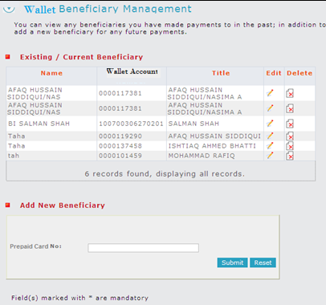

Figure – Wallet Account Management Page

The compact page is divided into two sections:

**Existing/ Current Beneficiary**

This section displays all the existing beneficiary records in a table. The following information about each beneficiary is displayed:

* Name of the beneficiary (assigned when adding a new beneficiary)
* Wallet Account Number
* Account Title

The table also presents options to “Edit” and “Delete” a beneficiary record

**Navigation**

The following navigation links/ options will be available on this section:

|  |  |  |
| --- | --- | --- |
| Option | Type | Description |
| Edit | Linked Icon | Opens a page to edit the corresponding beneficiary record |
| Delete | Linked Icon | Proceeds to delete the corresponding beneficiary record |

**Add New Beneficiary**

This section allows for creating a new beneficiary record in the application, which can then be used/ referenced during Fund Transfers (JS-to-Wallet) transactions.

**Input Fields**

|  |  |  |  |  |  |
| --- | --- | --- | --- | --- | --- |
| Field | Type | Length | Mandatory | Enabled | Description |
| Wallet Account | TextBox | 1 – 20 | Y | Y | The beneficiary’s account number |

**Navigation**

The following navigation links/ options will be available on this page:

|  |  |  |
| --- | --- | --- |
| Option | Type | Description |
| Submit | Button | Title fetch for wallet account |
| Reset | Button | Clears the input/ selections made on the form |

Upon pressing the Submit button if the Wallet Account Number fails to be verified, an error message is displayed. Else, the following page is displayed:

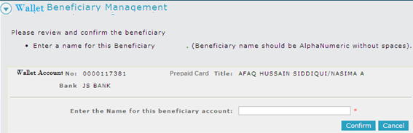

Figure - Wallet Beneficiary Management - Add Beneficiary

As a result of the verification via the Title Fetch transaction, the following information returned is displayed on screen:

* Wallet account number provided by the user
* Card Title as returned by the verification transaction

**Input Fields**

|  |  |  |  |  |  |
| --- | --- | --- | --- | --- | --- |
| Field | Type | Length | Mandatory | Enabled | Description |
| Beneficiary Name | TextBox | 1 – 30 | Y | Y | Name/ alias assigned to the beneficiary record |

**Navigation**

The following navigation links/ options will be available on this page:

|  |  |  |
| --- | --- | --- |
| Option | Type | Description |
| Confirm | Button | Submits the form and proceeds to save the beneficiary record. |
| Reset | Button | Clears the input/ selections made on the form. |

**Edit Beneficiary**

Option for “Editing” a beneficiary record will be available against each row in the grid. Upon clicking the “Edit” option, the user would be taken to the following screen:



Figure - Wallet Beneficiary Management - Edit Beneficiary

The screen is similar to “Add Beneficiary” page and would allow the user to edit the Beneficiary Name (alias) only.

**Input Fields**

|  |  |  |  |  |  |
| --- | --- | --- | --- | --- | --- |
| Field | Type | Length | Mandatory | Enabled | Description |
| Beneficiary Name | TextBox | 1 – 30 | Y | Y | Name/ alias assigned to the beneficiary record |

**Navigation**

The following navigation links/ options will be available on this page:

|  |  |  |
| --- | --- | --- |
| Option | Type | Description |
| Confirm | Button | Submits the form and proceeds to update the beneficiary name. |
| Reset | Button | Clears the input/ selections made on the form. |

#### Delete Beneficiary

As shown in Figure 11, option for “Deleting” a beneficiary record will be available against each row in the grid. Upon clicking the “Delete” option, the user will be displayed a confirmation message:

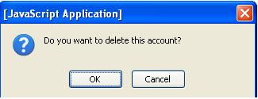

Figure – Wallet Beneficiary Management - Delete Beneficiary Confirmation

**Navigation**

The following navigation links/ options will be available on this page:

|  |  |  |
| --- | --- | --- |
| Option | Type | Description |
| OK | Button | Proceeds to delete the beneficiary record. A status message is shown to the user upon successful deletion |
| Cancel | Button | Cancels the operation and remains on the same page |

-

1. Out of scope

Below are the snap shots of items out of scope;

* Phase 1 scope covers JSBL Account to Wallet Account transfer only
* Limits and Permissions management for Wallet accounts is out of scope
* 1Link UBPS Billing Aggregator will be integrated with RDV. Integration with any other Billing aggregator will be out of the scope
* Beneficiary Management is also considered as scope as per client request.
* No new reports will entertain in Vision.
* Only Flat file format for vision import included in the scope.



**Dubai – UAE**

Adroit Technology  
Post Box No. 74475  
Suite No. 1904, City Tower 2, Sheikh Zayed Road, Dubai, UAE.  
Tel: +971 4 3887731

**Karachi – Pakistan**

Suite No. 201, 2nd Floor, Beaumont Plaza, Beaumont Rd., Karachi-75530, Pakistan.  
Tel: +92 21 35675240-42  
Fax: +92 21 35675244

**Lahore – Pakistan**

Suite # 613, 6th Floor,  
Siddiq Trade Centre,  
72, Main Boulevard,

Gulberg, Lahore.Pakistan.  
Tel: +92 42 35787565-66

For Further Inquiries:

**Email: info@avanzasolutions.com**

**URL: www.avanzasolutions.com**